**Career Plan Template**

**Format: Font: Verdana 12**

1. **Draw your road map or your career plan (30%)**

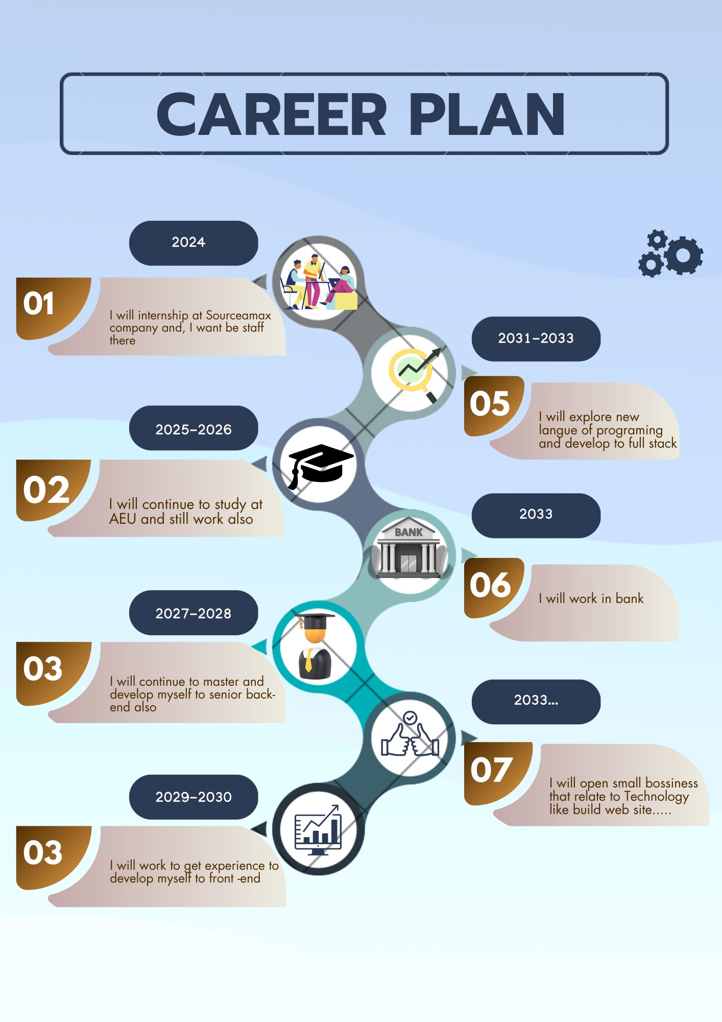

1. **Write reports with guidance questions (65%)**

|  |
| --- |
| 1. What is your professional goal? 15% |
| My professional goal is Back-end developer |
| 1. What are your strengths and weaknesses? 10% |
| - My strengths are  . My skills that, I learn in nowadays doesn’t relate to requirement of company  . I don’t have company to works  . My English is low  - My weaknesses  . Research  . PHP  . English |
| 1. What kind of company do you want to work? And why? 10% |
| The kind of company that I want to work is solution company, because there are big company learn a lot of new langue of programing like Java C++ C#... and also has a lot of position |
| 1. How do you plan to update yourself? 10% |
| - I will review all of the langue that, I learned already like Java script, PHP Algorithm, and Note Js. everyday by prepare schedule and English also.  - I will improve my soft skills such as, communication, teamwork, problem solving, and responsibility.  - I will explore new langue of programing by research on internet |
| 1. How is the future of the IT job market? 10% |
| - Grow up in the world  - Develop more than nowadays  - Everything is will use IT a lot |
| 1. How do you adapt yourself to the IT job market? 10% |
| - I will Develop myself depend situation of IT  - I will learn new something that relate to IT job |

1. Attach one JD of your ideal job (5%)

Job : Back-end developer

